TEST RESULTS:

1.When the message passing is successful.

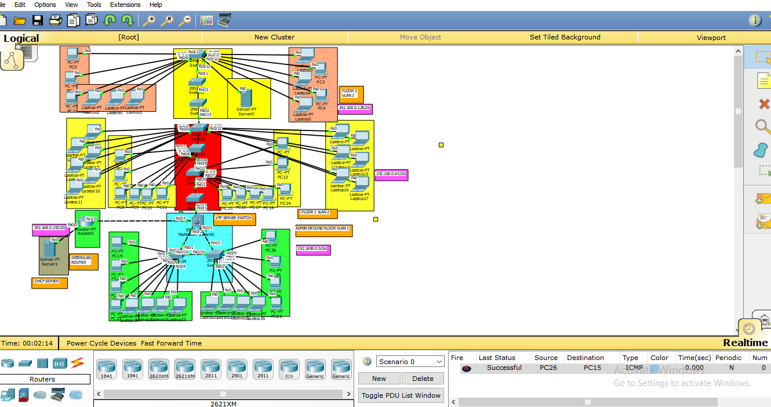

2. When message is passed to unauthorized PC, the transmission is unsuccessful/failed.

